Diary No. 8

Digital to Physical

Team Members: Ali Noorani, James Wilson, Samiul Bari, Will Connell.

* The Game Premise:

The game was inspired from Minecraft, where the player would need to mine and reach the diamonds before the other players in the same fashion as the regular Minecraft game.

* Rules and Mechanics:

The end goal was to mine diamonds. The player who mines the diamonds first wins. The player needs to go through a set of task to successfully mine diamonds. There is a major element of chance within the game.

* Materials:
  + The game board (See Figure 1).

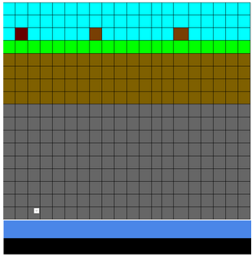

A

B

C

D

Figure 1 - the game board, [A] tree level, [B] dirt level, [C] stone level, [D] diamond level.

* + The cards containing the objects gathered in the game (see Table 1).

|  |  |  |
| --- | --- | --- |
| **Item** | **How to obtain it** | **Quantity** |
| Crafting table | Make with 4 wood | 4 (1 per player) |
| Furnace | Make with crafting table and 8 stone | 4 (1 per player) |
| Wooden Pickaxe | Make with crafting table and 5 wood | 4 (1 per player) |
| Stone Pickaxe | Make with crafting table, 2 wood, and 3 stone. | 4 (1 per player) |
| Iron Pickaxe | Make with crafting table 2 wood, and 3 iron. | 4 (1 per player) |
| Wood | Mine with hands when on a tree block (rolling a 1-3 on an tree block) | 50 |
| Stone | Mine with wooden pick (rolling a 5 or 6 in a stone block) | 50 |
| Iron Ore | Mine with stone pick (rolling a 3, 4 in a stone block) | 15 |
| Iron | Smelt using a furnace, 1 coal, 1 iron ore | 15 |
| Coal | Mine with stone pick (rolling a 1,2 in a stone block) | 15 |
| Diamonds | Mine with a iron pick at … | 1 |

Table 1 Showing the different cards obtainable by the player.

* + A 6D die.
* How to Play:
  + At the start of the players turn, they roll the dice to see how many spaces/blocks they are able to move.
  + The players will first need to get wood and make a crafting table and a wooden pickaxe.
  + Next they’ll need to mine stone and make a stone pickaxe with the wood they have left.
  + Then they need to mine coal and iron ore to smelt the iron ore and make a iron pickaxe.
  + Finally they will mine down to diamond level and mine their first diamonds.
  + Depending on what block they land on they reroll the dice to see what material they collect. If they are in the air blocks, they can mine wood, if they are in the dirt, they can only move, if they are in the stone level, they can move and mine iron, stone and coal and if they are in diamond level they can mine diamonds or stone.
* Play Testing:

The play testing feedback the team got was:

* + - “The game seems fun to play.”
    - “Need to add enemies into the game so the player can die.”

Play Tester: Reece Taylor

The solution the team came up with for this was that there would now be a chance for lava to come up in the stone level that can kill the player in one hit. If the player now rolls a 1, then lava will spawn and kill the player. 2 is coal. 3-4 is iron. 5-6 is stone.

* Working in teams to solve problems:

The team ran into a problem when deciding what mechanics of the original game to keep and which to discard. In the end the team came up with a solution everyone agreed on.

* Improvements in the Team:

The team worked smoothly throughout the entire game making process and delivered the presentation successfully within the time limit and effectively.